
PES University
(Established under Karnataka Act No. 16 of 2013)
100 feet Ring Road, BSK 3rd stage, Hosakerehalli, Bengaluru - 560085
Department of Computer Science & Engineering

UE23CS320B -CAPSTONE PROJECT PHASE–2 REPORT GUIDELINES
Report Format
Paper: A4 size
Margins: 2.0 cm on all sides (top, bottom, left, right)
Spacing: 1.5 line spacing
Font: Times New Roman
Font Sizes:
Chapter title – 18 (centered)
Section title – 16 (bold, left)
Subsection title – 14 (bold, left)
Body text – 12 (justified)

Report Order
Inner Title Page & Certificate
Company Certificate (if any)
Acknowledgement
Abstract
Table of Contents
List of Tables and Figures

Table of Contents Must Include
Introduction (1 page)
Literature Survey (2 pages)
Architecture with Explanation (1-2 pages)
Methodology (1-2 pages)
Implementation (Salient Modules)(2 pages)
Results (1-2 pages)
Conclusion and Future Work (1 page)
References (1 page)

Chapter Numbering
Use Arabic numbers (1, 2, 3...)
Sections: 2.1, 2.2
Subsections: 2.2.1, 2.2.2
Figures, Tables, and Equations
Number them chapter-wise (e.g., Table 2.1, Figure 3.2).
Equations should also be numbered in decimal form.
Use SI units only.
Writing & Presentation
- Avoid copying text directly (no plagiarism).
- If you quote, use quotation marks and give a reference.
- Keep writing clear, correct, and well-organized.
Header & Footer Rules
- No header on the first page of each chapter.
- Footer only on chapter opening pages.
- Headers and footers start from the Introduction chapter.

Conclusion Chapter
- Summarize what was done in Phase–2 and write a note on future work.

Reference or Bibliography
The reference should be numbered serially in the order or their occurrence in the text and their numbers should be indicated within square brackets for example:
[1] W. M. Dorsey, A. Stumme, K. M. Charipar and N. A. Charipar, "3-D-Printed Circular Array for WiMAX Base Station," in IEEE Antennas and Wireless Propagation Letters, vol. 18, no. 6, pp. 1159-1163, June 2019, doi: 10.1109/LAWP.2019.2911354.

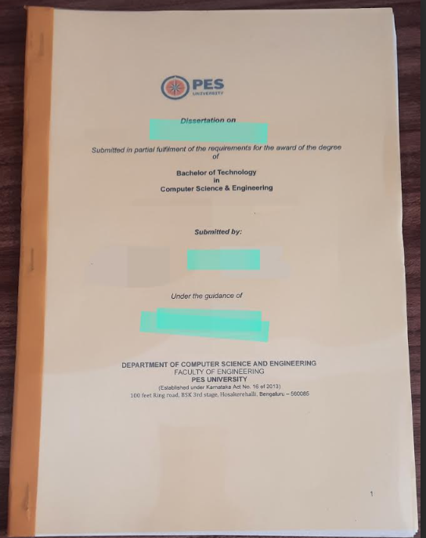
Picture of Soft bound Hard copy of Report for your reference

